1. Indicate the changes (using the shorthand representation) that you would need to make to the original TAL Distributors database design (see Figure 2-1) to support the following requirements. A customer is not necessarily represented by a single sales rep, but can be represented by several sales reps. When a customer places an order, the sales rep who gets the commission on the order must be in the collection of sales reps who represent the customer.

For a single CUSTOMER to have various sales REPs associated to them, we could remove the association of sales REP from the CUSTOMER information table, instead placing it in the ORDER_LINE table.

CUSTOMER

( CUSTOMER_NUM, CUSTOMER_NAME, STREET, CITY, STATE, POSTAL_CODE, BALANCE, CREDIT_LIMIT )

ORDER_LINE

( ORDER_NUM, ITEM_NUM, NUM_ORDERED, QUOTED_PRICE, **REP_NUM** )

This way, numerous sales REPs can be associated to an order without having to have multiple CUSTOMER entries on the CUSTOMER table with only the sales REP field being different.

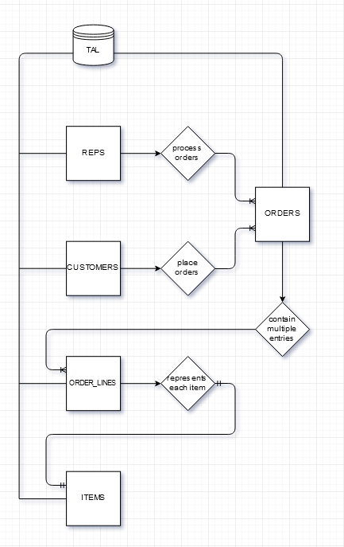**2.** There is no relationship between customers and sales reps. When a customer places an order, any sales rep can process the order. On the order, you need to identify both the customer placing the order and the sales rep responsible for the order. Draw an E-R diagram for the new design.

For this example, I’ll repeat what I did before in #1, except putting the REP_NUM in ORDERS instead of ORDER_LINE.

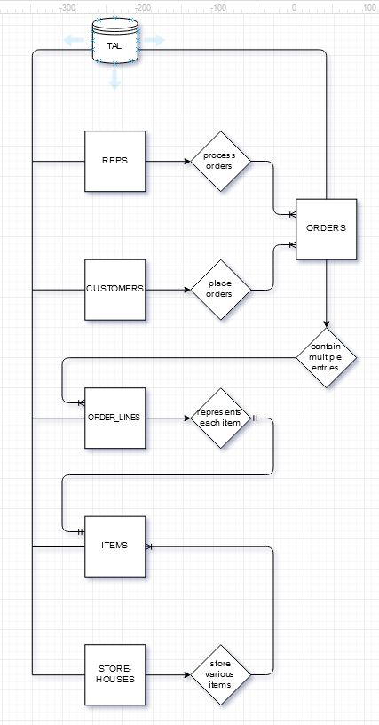**3.** For an item, store the item’s number, description, category, and price. In addition, for each storehouse in which the item is located, store the number of the store- house, the description of the storehouse, and the number of units of the item stored in the storehouse. Draw an E-R diagram for the new design.

**ITEM**

**( ITEM_NUM,**

**DESCRIPTION,**

**CATEGORY,**

**PRICE,**

**STOREHOUSE_NUM**

**)**

**STOREHOUSE**

**( STOREHOUSE_NUM,**

**DESCRIPTION,**

**INVENTORY**

**)**

**4.** Using your knowledge of TAL Distributors, determine the functional dependencies that exist in the following table. After determining the functional dependencies, convert this table to an equivalent collection of tables that are in third normal form.  
ITEM (ITEM_NUM, DESCRIPTION, ON_HAND, CATEGORY, STOREHOUSE, PRICE,  
(ORDER_NUM, ORDER_DATE, CUSTOMER_NUM, CUSTOMER_NAME, NUM_ORDERED, QUOTED_PRICE))

CUSTOMERS

( CUSTOMER_NUM, CUSTOMER_NAME )

ORDERS

( ORDER_NUM, CUSTOMER_NUM, ORDER_DATE )

ORDER_LINE

( ORDER NUM, ITEM_NUM, NUM_ORDERED, QUOTED_PRICE )

ITEMS

( ITEM_NUM, DESCRIPTION, CATEGORY, PRICE, STOREHOUSE_NUM )

STOREHOUSES

( STOREHOUSE_NUM, ITEM_NUM, ON_HAND )

1. List the first and last name of each guide that lives in Maine (ME).

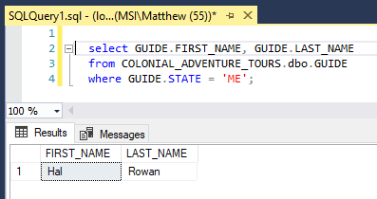

2. List the trip name of each trip that has a maximum group size of greater than 16.

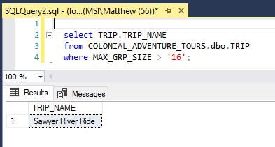

3. List the trip ID and trip name of each trip that has the type Paddling.

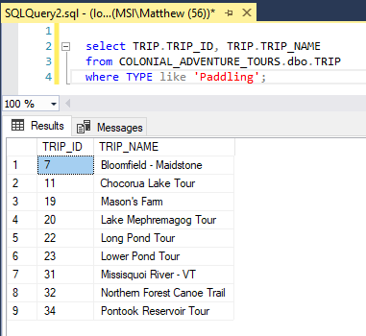

4. List the trip ID and trip name of each trip that has the type Biking and that has the season Early Fall. 